**Practical No:02**

**Downloading and installing Python, run a simple program on Python interpreter.**

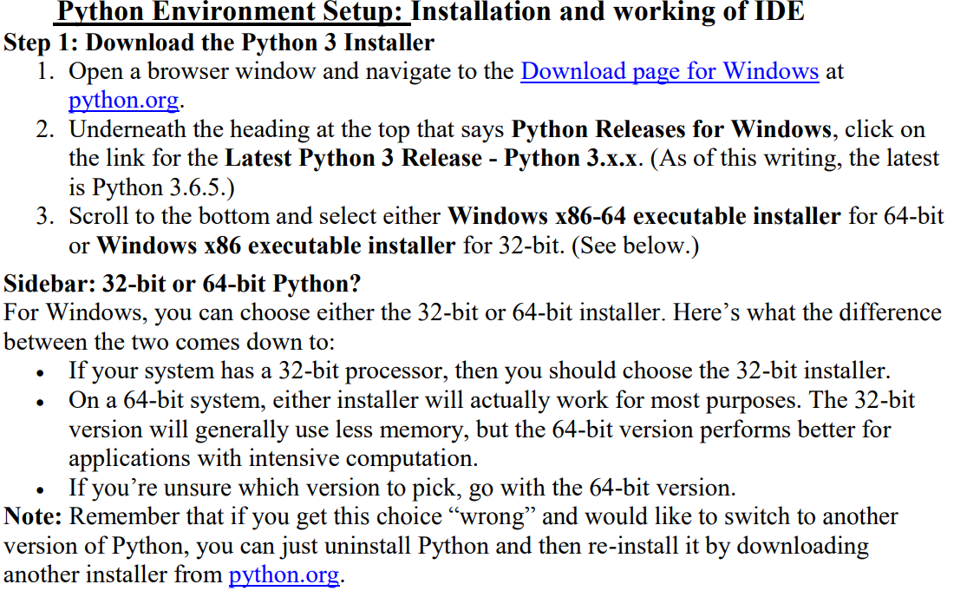

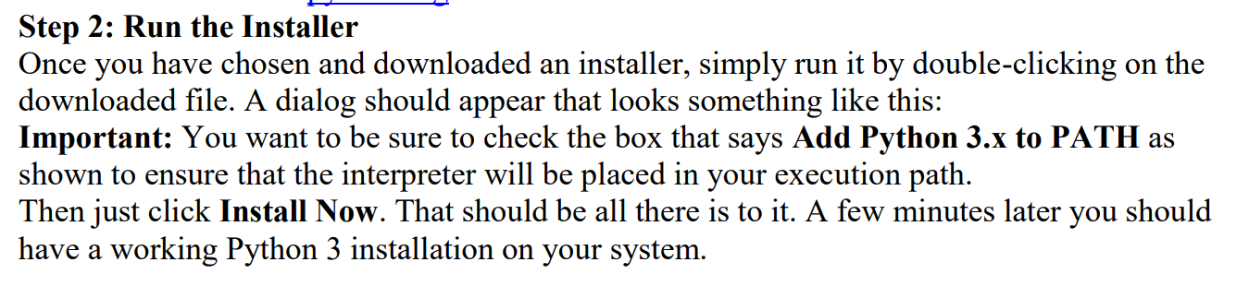

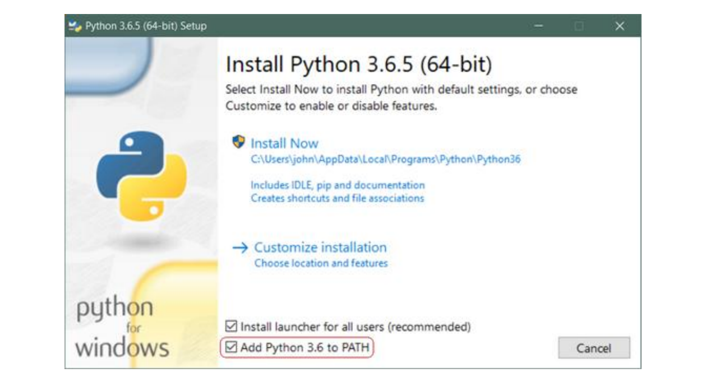

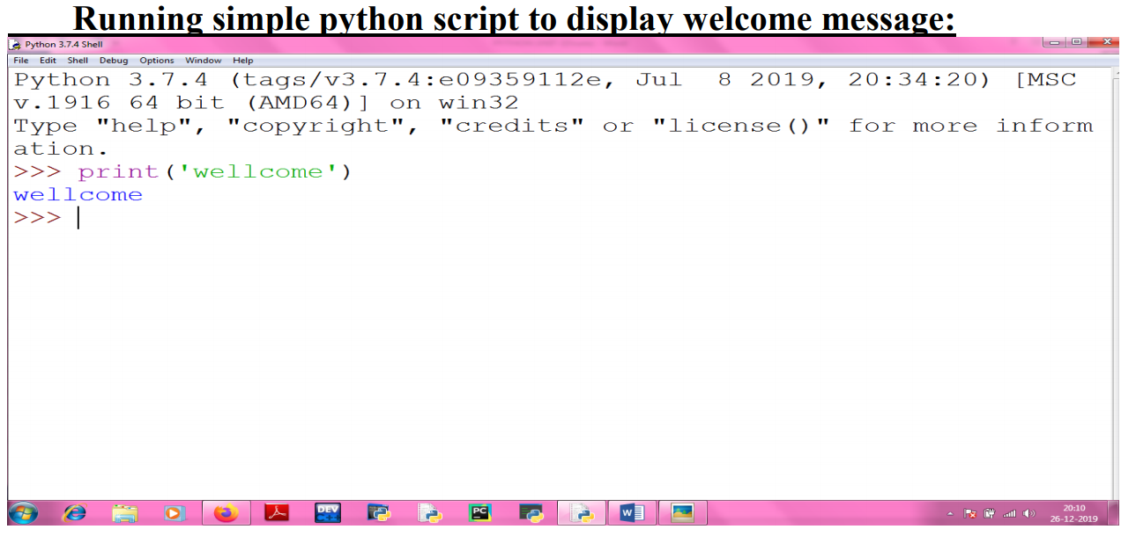

**Result: We have successfully studied Python Setup Process.**